Play 1 Nature

Daphne O. Pack
Department of Home and Family, Brigham Young University-Idaho
CHILD310: Early and Middle Child Development
Brother Rowe
Oct. 27, 2025

For this assignment, I played out in the gardens with Aubrey, Bekah, and Phebe from class. The activity we chose to do was an outdoor treasure hunt with common items found in the gardens (Marotz, 2023). We adjusted it to be like an I-Spy game where we were each assigned a texture (pokey, smooth, rough, soft) and had three minutes to find something red that was that texture. We then repeated this with the colors orange, yellow, and green. At the end we arranged our assorted items to spell out the word “fall.”
Something that made this activity play was that it was exploration. We each had the opportunity to search the gardens high and low for leaves, twigs, rocks, berries, and flowers that fit our criteria. Another aspect of this play was it was pleasurable. We really enjoyed being outside, being together, and taking the time to notice the world around us—big and small. Even though it was partly motivated by this assignment, our desire to create and find the perfect objects was intrinsically motivated, which is another aspect of play.
This activity addressed all areas of development including motor, perceptual-cognitive, speech and language, and social-emotional. According to Marotz (2023), a 5-year-old child should be able to “reproduce many shapes and letters”, which is a fine motor skill. We incorporated that into our play by using the objects we found to create letters. This activity also used a lot of perceptual-cognitive skills like following three step directions, sorting objects based two qualities such as color and texture, sorting a variety of objects so that all things in the group have a single common feature, and knowing the alphabet. Our activity also included the speech and language skill of identifying and naming four or more colors and the social-emotional skill of following directions and carrying out assignments. (Marotz, 2023).
While playing I felt like a kid again. I felt free to explore and like I didn’t have a care in the world. The only thing I was worried about was finding something pokey and orange. It was fun to do this activity with the other girls and just enjoy being outside. I was surprised by how many things there were to find and the criteria we’d set challenged me to think outside the box. Afterwards I felt calmer and more in touch with nature. It really lifted my spirits and cleared my head to be outside and play a simple game. It also would’ve been very different if I’d been alone. I still would’ve considered it play and I would’ve enjoyed it, but being with my friends made it more of a game with a little competition and collaboration. We were each assigned a different texture to find so we worked together to achieve a greater goal. This fun game also helped us bond with each other.
Playing is so rewarding and fun but incorporating it into the life of a busy student is the hard part. I think the best part about play is that you can do it pretty much anywhere, anytime. Play is just something that’s enjoyable, exploratory, and intrinsically motivated. Even just fifteen minutes between classes of finding shapes in the clouds or taking a study break to wrestle with a roommate or spouse would have the benefits of play. Another idea would be to purposefully schedule a time to get together with friends and play a game or sport.
This activity we did was perfect because it only took a half hour and it could easily be adapted to involve young children. Something I would do to include 5-year-olds would be to first teach them about textures, so they know what they’re looking for, or ask them to find shapes instead. Another thing I could do would be to ask them to find a certain number of objects (like five) of a specific color. Then when they all returned, we could feel and discuss the textures of the items found. Then we could sort the items by color, shape, or texture. I liked the idea of using the items to form letters, so we could adapt it to have each child use one color to make the first letter of their name as well.
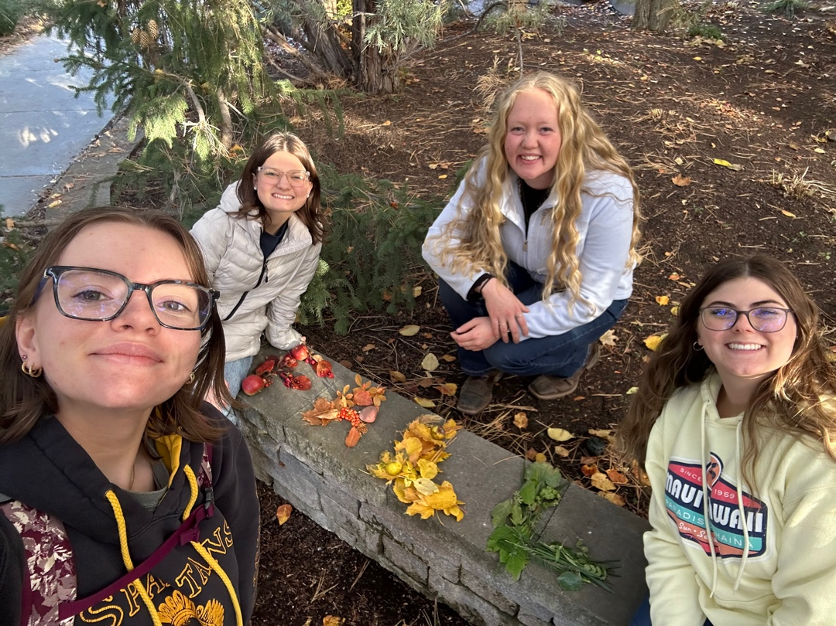
Personal play in my day-to-day life will help me relate better to children I will work with and my own children in the future. The more in tune I am with my “inner child,” the more I’ll be able to understand and support them in their development. Also, I think a caregiver or parent who plays with or alongside children will be more likely to form strong bonds of trust and security with them.
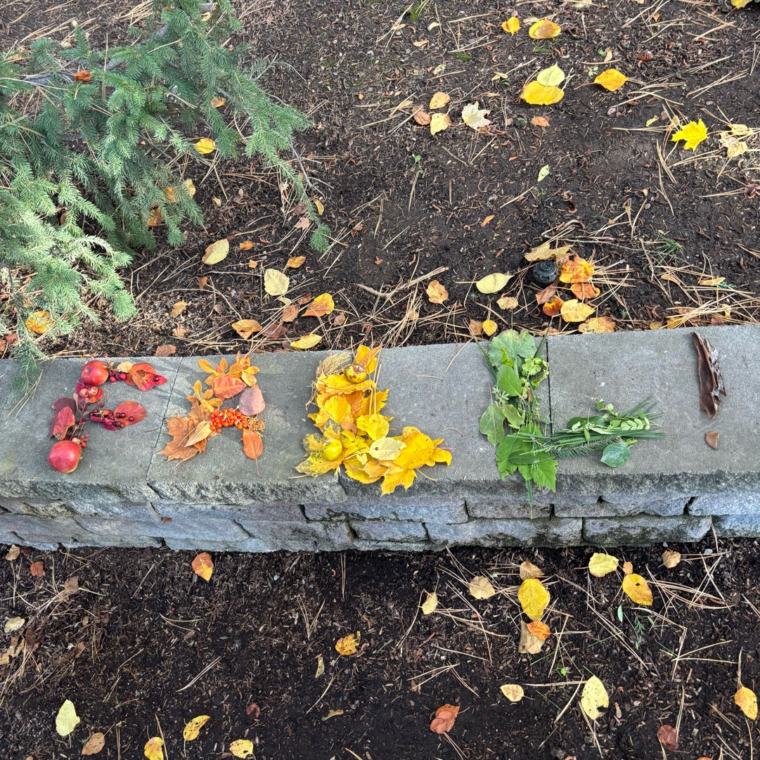
Reference
Marotz, L. R. (2023). Developmental profiles: Pre-birth through adolescence. 9, 156-162.

